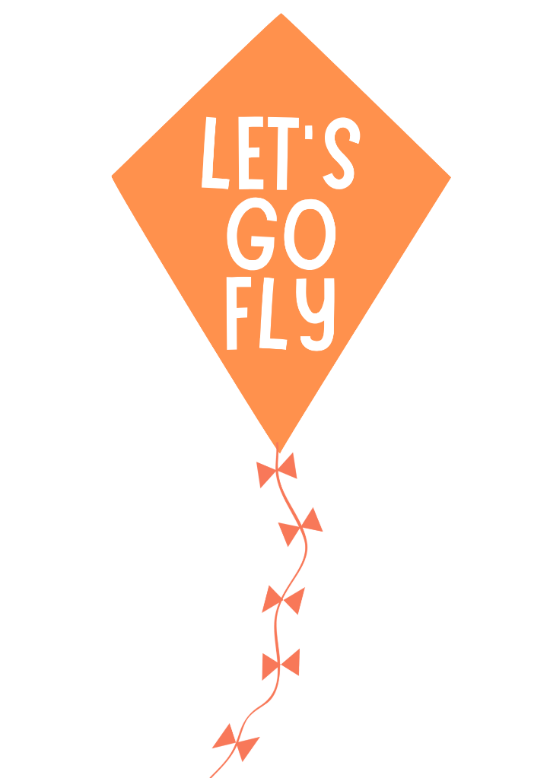
Dorchester kite festival
Name of Child: |  | Click or tap here to enter text. |  |  | Age: |  | Click or tap here to enter text.
Name of Parent/Guardian: |  |  | Click or tap here to enter text.
Postcode: | Click or tap here to enter text. |  |  | Tel/Mobile: |  | Click or tap here to enter text.
Parent’s email: |  | Click or tap here to enter text.
Do you allow us permission to use your design for future marketing? |  |  |  |  |  |  |  | ☐Yes / ☐No
Parent/guardian please complete so we can find our winner! BLOCK CAPITALS

Enter by Midday Friday 15th May 2026
To enter, send your entry form & design to us by
Email: conniehollings@dorchester-tc.gov.uk
Post/drop-off: Dorchester Town Council, 19 North Square, Dorchester, DT1 1JF
Help launch Dorchester’s first ever Kite Festival by designing a kite to represent our town. Take inspiration from the landscape, places, and people to create ‘A Celebration of Dorchester’. Use your creativity and imagination to decorate the template on the reverse of this sheet.
Designs will be judged by the Mayor of Dorchester. The winning design will be made into a real kite by an artist and flown by the Mayor to start and end the festival!
Please don’t forget to fill in your contact details so we can get in touch with the lucky winner.
Design a Kite Competition!
Sat 6TH June, 11am-4.30pm
The Great Field, Poundbury

My Celebration of Dorchester!

